Helpline Volunteer
Application Form

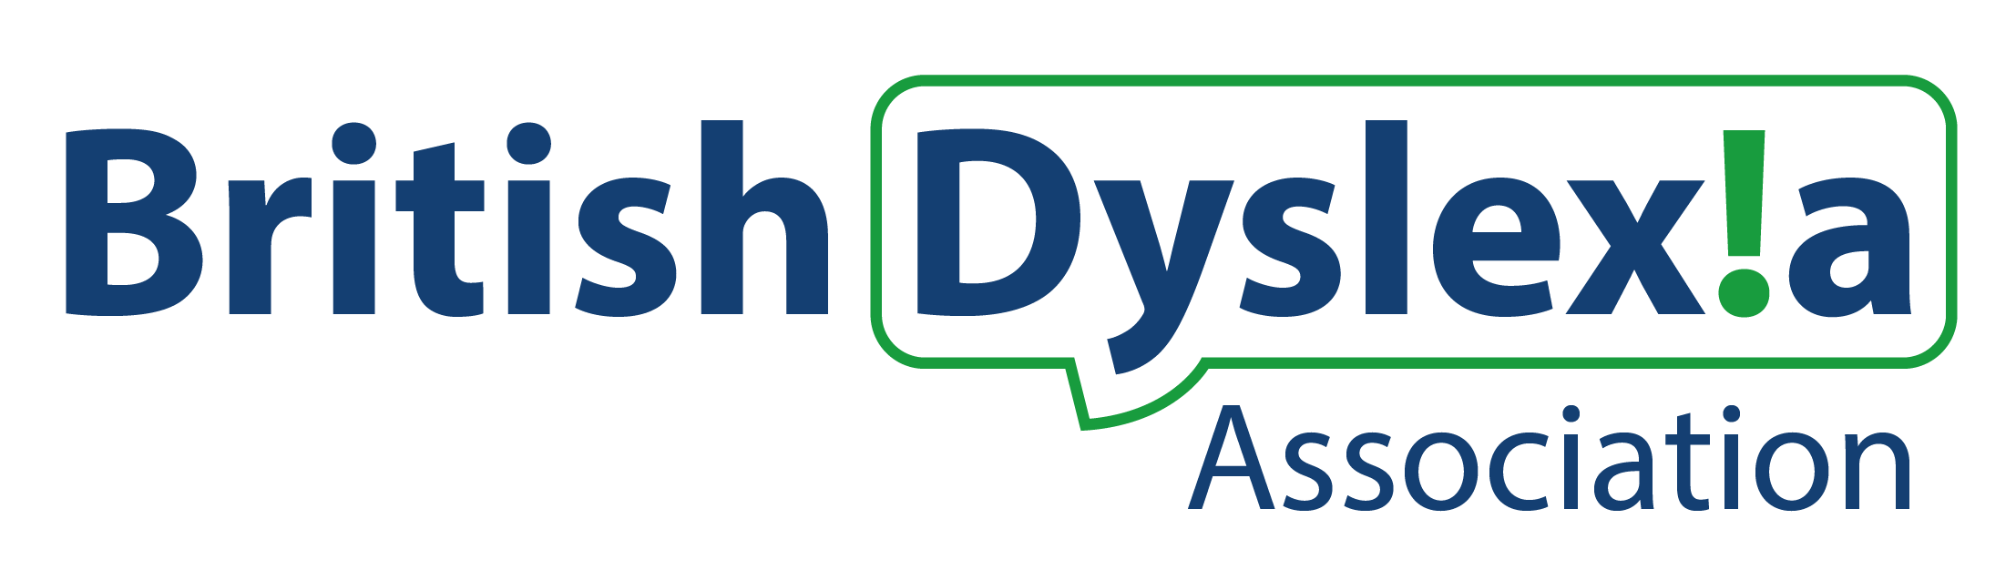

Helpline Volunteer
Application Form - Confidential
Thank you for expressing an interest in volunteering for the British Dyslexia Association. Please complete this application form and return it to: volunteer@bdadyslexia.org.uk
Personal Details
Name
Address | Postcode:
Phone | Home:  Mobile:
Email
Preferred method of contact

Please tell us a bit about yourself and why you’re interested in the helpline volunteer role:

Can you tell us about your understanding of what dyslexia is (and other specific learning difficulties) and what type of support is available for people in education and in the workplace.
Please tell us about any work, volunteering, personal experience or skills that you have that are relevant to the role you are interested in:

Do you have any particular needs that we should be aware of so as to best support your volunteering with us?

Have you applied to us before?
Yes ¨ No ¨

References
To complete your application, we need you to supply us with two people who know you well enough to comment on your suitability for this role. They should not be family members. If you are not sure about who to put we are happy to discuss this with you.

Referee 1
Name:
Address: | Postcode:
Phone:
Email:
How does this person know you?
How long has this person known you?

Referee 2
Name:
Address: | Postcode:
Phone:
Email:
How does this person know you?
How long has this person known you?

Where did you hear about volunteering opportunities at the BDA?

Please confirm that you are over the age of 18 Yes ¨

Disclosure and Barring Service
Have you had any cautions, criminal convictions or criminal convictions pending, warnings or reprimands?
Yes ¨ No ¨
If yes, please state their nature:

Date of conviction(s):

Please confirm that you agree to a basic Disclosure and Barring Service check Yes ¨ No ¨

Signed:
Date:

Thank you for taking the time to complete this form. Please return this form to: volunteering@bdadyslexia.org.uk

Equal Opportunities Monitoring Form - Confidential
This information will be treated in the strictest confidence and will only be used to monitor the diversity and inclusivity of our volunteer programme and how representative it is of our community.
There is no obligation to complete this form. Completion of this form constitutes an agreement that the information can be held electronically by the British Dyslexia Association. We will store this information securely and act in accordance with our Data Protection Policy.
- Volunteer role:
- Gender:
Female: ☐ Male: ☐ Transgender: ☐ Non-binary: ☐
Prefer not to say: ☐
- Age range:
18-25: ☐ 26-35: ☐ 36-45: ☐ 46-55: ☐ 56-65: ☐ 66+: ☐ Prefer not to say: ☐
- Disability: The Equality Act 2010 defines a disabled person as someone who has a physical or mental impairment which has a substantial and long-term adverse effect on their ability to carry out normal day-to-day activities. Taking this into account, do you consider yourself to have a disability?
Yes: ☐ No: ☐
- Sexuality:
Heterosexual: ☐ Lesbian/Gay: ☐ Bisexual: ☐
Prefer not to say: ☐

- Ethnic group:
White: British: ☐ European: ☐ Irish: ☐
Other white (please state): ☐

Black or Black British: African: ☐ Caribbean: ☐
Other black (please state): ☐

Asian or Asian British: Indian: ☐ Pakistani: ☐ Bangladeshi: ☐
Other Asian (please state): ☐

Mixed: White & Black African: ☐ White & Black Caribbean: ☐
White & Asian: ☐ Other mixed (please state): ☐

Chinese: Chinese: ☐ Chinese British: ☐
Other Chinese (please state):

Other ethnic group (please state): ☐ Not known: ☐ Prefer not to say: ☐

- Religion / belief:
Christian: ☐ Muslim: ☐ Hindu: ☐ Sikh: ☐ Jewish: ☐ Buddhist: ☐ Atheist: ☐
Prefer not to say: ☐
Other (please state):

- All languages spoken:
Preferred spoken language:

